Endocrine System Class Activity

Part B: Cushing’s Syndrome (30 min)
Chronically high levels of glucocorticoids can result in obesity, muscle weakness, and depression, a combination of symptoms called Cushing’s syndrome.

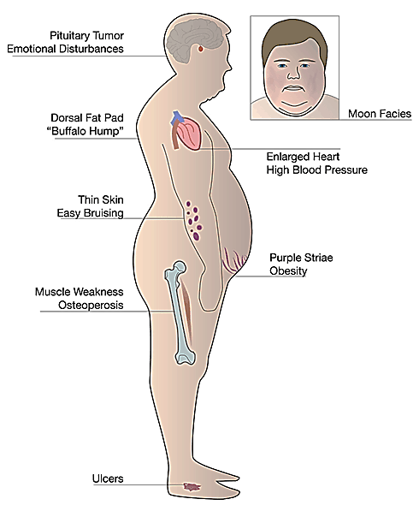
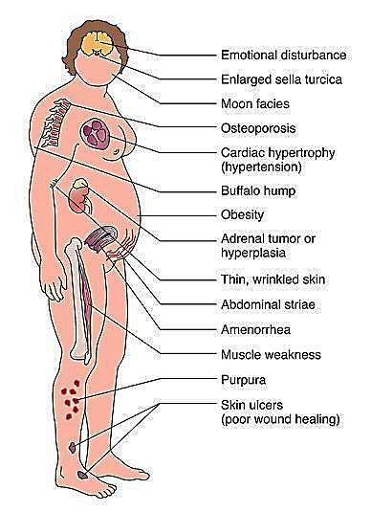

- Excessive activity of which endocrine gland(s) could result in Cushing’s syndrome?

- To determine which gland has abnormal activity in a particular patient with Cushing’s syndrome, physicians use the drug dexamethasone (a synthetic glucocorticoid). The release of which tropic hormone is affected by the administration of this drug? What is the effect of dexamethasone administration on this tropic hormone?

In a patient affected by Cushing’s syndrome, dexamethasone was administered and the levels of blood cortisol were measured in triplicates. The following results were obtained.

Individuals | Cortisol in blood (µg/dL)
 | No drug administered | Dexamethasone administered
Normal individual | 20.00±2.11 | 4.03±0.85
Patient with Cushing’s syndrome | 34.26±2.36 | 30.74±3.41

- Draw a graph that compares the levels of cortisol in both individuals. Label your graph appropriately.

- Which statistical test would you perform in order to determine whether the difference in blood cortisol levels in the patient with Cushing’s syndrome is significant?

- Based on the cortisol levels obtained above, which endocrine gland is affected in the patient with Cushing’s syndrome? Explain.

