Module 6: Ecology
Review Activity
Disappearing Sea Otters
Dr. James Estes has studied sea otters off the coast of Alaska since the 1970s. Once an endangered species as a result of fur trading, otter populations recovered and appeared very healthy and robust in the early 1980s. However, starting in the early 1990s, Estes and his colleagues noted that otter population numbers were dropping precipitously.
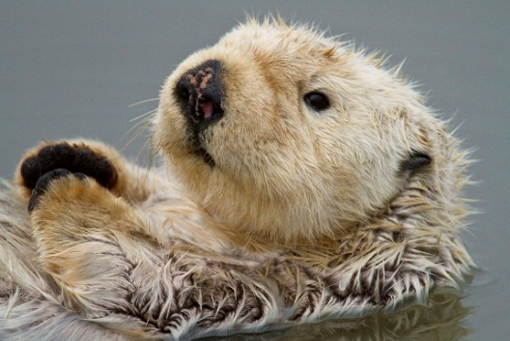
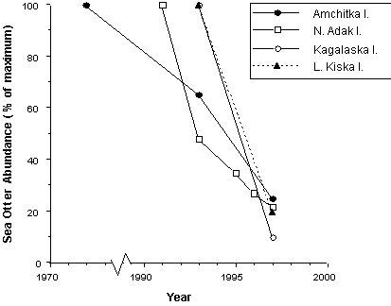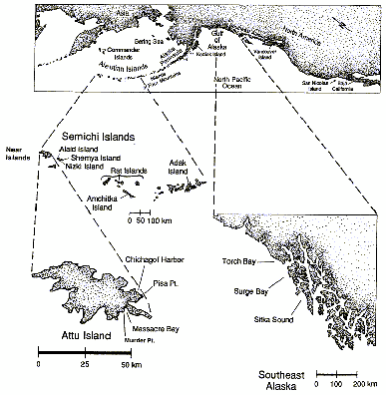

Changes in relative abundance of sea otters at several locations in the Aleutian Islands, Alaska.
(Redrawn from Estes et al., 1998.)
Map of the North Pacific Ocean showing the Aleutian Islands and some specific sea otter study sites. (From Estes, J.A., and D.O. Duggins. 1995)

The following excerpt from the New York Times describes the thought process and background research done by Estes and colleagues to examine this question:
Could the otters simply have migrated from one part of the region to another? To find out, the researchers analyzed populations over a 500-mile-long stretch of the Aleutians from Kiska to Seguam.... By 1993 otter numbers in that whole stretch had been cut by half. Here the geographical scope of the research effort became critical; a smaller region would not have been large enough to reveal the decline. In 1997, they ... found that the population decline had worsened, to about 90 percent....
"That told us for sure it was a very large- scale decline, but we were still trying to understand the cause," Dr. Estes said.... The researchers ... ruled out reproductive failure. Their studies enabled them to keep track of how often otters gave birth and how many young survived, and this revealed that reproduction was continuing to re-supply the population.
With other possible causes eliminated, ... mortality had to be the explanation. In the past, they had seen temporary declines in otter populations because of starvation, pollution or infectious disease. "In all those cases," Dr. Estes said, "we find lots of bodies. They get weak and tired and come ashore to die." This time not a single dead otter was found -- a clue, he said, that "something really weird was going on."
(Excerpted from Stevens, William K. "Search for missing sea otters turns up a few surprises." New York Times, January 5, 1999.)

- Based on the information presented above, propose a hypothesis for what could be causing the decline in sea otter numbers.

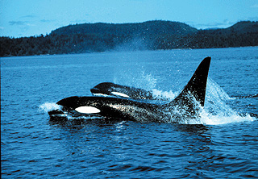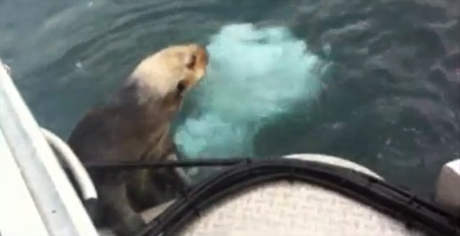
https://www.youtube.com/watch?v=k5Eo2FGeEyg
Estes and his group hypothesized that increased predation by killer whales was the cause of the sea otter decline. This was an unusual idea, since killer whales and sea otters had been observed together in Alaska for decades with no obvious interactions occurring between them. The first time a killer whale was observed attacking a sea otter was in 1991. Nine more attacks were observed in the next seven years and it was these attacks that finally led Dr. Estes and his colleagues to propose their hypothesis.
They estimated the impact of killer whales on sea otter populations by comparing trends in population size and survival rates of individually marked otters between two adjacent locations on Adak Island: Clam Lagoon and Kuluk Bay. Kuluk Bay is on an open coast, so sea otters there are exposed to killer whales. In Clam Lagoon, the entrance from the open sea is too narrow and shallow for killer whales to get in.
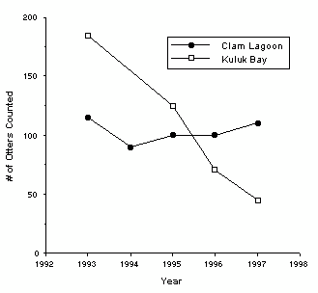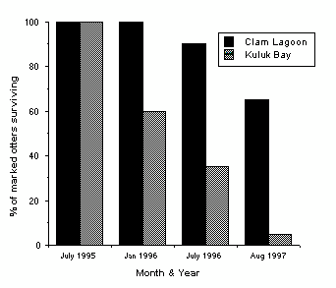
Changes in sea otter population size over time at Clam Lagoon and Kuluk Bay, Adak Island, Alaska. Redrawn from Estes et al., 1998.
Survival rates of sea otters individually marked in 1995 with flipper tags and radio transmitters at Clam Lagoon and Kuluk Bay, Adak Island, Alaska. Redrawn from Estes et al., 1998.

- The two graphs above simply present visuals of count data, and no summary or inferential statistics were necessary. What biological conclusions can be drawn from these two figures?

Killer whale and sea otter energetics
Estimated number of Aleutian Island sea otters eaten, 1990-1996 | 40 000
Adult sea otters
Average caloric content | 1.81 kcal/gram wet weight
Average mass, male | 34 kg
Average mass, female | 23 kg
Killer whales
Average field metabolic rate | 55 kcal/kg of whale/day
Average mass, male | 5600 kg
Average mass, female | 3400 kg

Using the table above, it’s possible to calculate that only 3.6 male killer whales, feeding exclusively on otters, would be able to account for the decrease in otter population over the six years (try to calculate this number yourself). Of course, killer whales would not feed exclusively on otters, but, conversely, there are much more than just 4 killer whales patrolling the Aleutian Islands. Thus, it seems entirely reasonable that killer whales could account for the decrease in otter numbers.

This, of course, begs the very important question: Killer whales and sea otters had co-existed peacefully for decades prior to the 1990s, so why would the whales suddenly start eating otters?
- Propose at least one, and maybe several different hypotheses for why whales would begin eating otters.

Estes et al. (1998) proposed a hypothesis to address this question. Their hypothesis incorporated the following elements:
- The species composition of Bering Sea fish changed dramatically in the decades preceding the 1990s. Oily fish species, such as ocean perch (a rockfish) and herring, declined sharply, while the abundance of pollock, a less oily fish, increased. The causes of these changes in the fish community are not clear. Several plausible hypotheses have been proposed, including overexploitation of perch and herring by humans through the 1960s and the warming of the northern Pacific in the 1970s, which may have made the temperature unsuitable for some species. Human hunting of plankton-feeding baleen whales may even indirectly play a role. Since pollock are also plankton feeders, a reduction in whales may have allowed pollock to proliferate.
- Steller sea lion and harbor seal populations in the North Pacific collapsed starting in the late 1970s. The decline in oily fish species may have contributed to this collapse, because, although pollock were increasingly available as an alternate food and are eaten by sea lions and seals, they are a less nutritious food and may not provide sufficient nutrition, especially for the growing juveniles. Whatever the cause, North Pacific harbor seal and sea lion populations had declined by as much as 80 percent by 1992.
- Killer whales are found in all oceans and seas from the polar regions to the tropics. They live in groups called pods, which appear to be of two genetically distinct types: transients and residents. Transients form smaller pods (one to seven individuals), roam over broader areas, eat predominately mammals (including seals, sea lions, and otters, but also other porpoises, and even large baleen whales, which they hunt and attack as a group), and vocalize (using a series of whistling noises) less. Residents form pods of five to 25 individuals, have smaller ranges, eat mostly fish, and vocalize frequently.
- Seals and sea lions (together called pinnipeds) insulate themselves in the cold ocean using a thick layer of blubber (fat), while otters insulate themselves based on two layers of hair, one of which traps air. As a result, pinnipeds have an average caloric content of 5.35 kcal/gram wet weight, as compared to 1.81 kcal/gram wet weight for otters. The pinnipeds are also much larger than the otters, with steller sea lion females averaging 300 kg (still MUCH smaller than a 4000 kg killer whale)

- Using this information, apply optimal foraging theory and a cost-benefit approach to analyzing animal behaviour to either refine one of your hypotheses from above or propose an entirely new hypothesis for why killer whales may have begun eating otters in the 1990s. In your response, compare and contrast the basic costs and benefits for an individual killer whale when choosing to eat an otter as compared to other mammal (or pinniped) prey, and then hypothesize why whales would make this choice.

- Based on your hypothesis and the cost benefit analysis above, make a prediction for how killer whale population numbers might have changed in the late 1990s and early 2000s. Explain the rationale behind your prediction.

In the early 2000s, and after over a decade of concerted conservation efforts, steller sea lion populations recovered somewhat, and stabilized at about 50% of pre-1970s levels. Based on this recovery, and with otter population levels so low, it seems that killer whales stopped hunting otters, or, at the very least, dramatically reduced their predation pressure. Consequently, otter populations also began to recover.

Below are demographic metrics for the Kuluk Bay sea otter population in 2000 and 2001:
Year | Population Size (estimate)
2000 | 27
2001 | 36

- If the population growth rate remained unchanged from what was observed between 2000 and 2001, estimate what the size of the otter population would have been in 2005.

As indicated in the table above, in 2001 the Kuluk Bay otter population consisted of 36 individuals. For the sake of this exercise, we will ignore E and I for population growth calculations.
Year | B | D
2001 | 15 | 4
2002 | 20 | 5
2003 | 25 | 8
2004 | 29 | 11

- Based on the data in the table above, complete the following table:
Year | N | r
2001 | 36
2002
2003
2004
2005

- Use the data from the table you just completed to plot a graph of otter population numbers in Kuluk Bay over the five year time period. Place this graph in the space below.

- What kind of population growth (approximately) is being demonstrated in the graph above? Why do you believe the population grew this way during the five year span?

- Would the population continue growing this way indefinitely? If yes, what would allow it to do so? If not, what would prevent it from doing so?

- Assuming no other changes occur in the populations of other species (whales, sea lions, oily fish, etc.) from 2000 levels, and given all of the information presented above, would you predict that the otter population in Kuluk Bay and those in other areas would eventually grow to reach pre-1990s numbers, i.e., population numbers before whales began preying on otters? Explain your answer.

The following five pages present information about and display data from a long-term and large-scale study of sea otters and kelp forest communities in southeast Alaska and the Aleutian Islands.
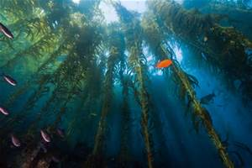
Kelps are large brown algae (protists), and a kelp forest is a large stand of individual kelps that grow to the surface and form a floating canopy. Kelp forests are highly productive ecosystems: productivity can be as high as 1500-3000 g Carbon/m²/year, which is comparable to the most productive terrestrial and aquatic ecosystems. Also, the tall (up to 30 m) bodies of the kelp individuals create a complex three-dimensional structure that supports a very diverse community of associated algal and animal species. For example, California kelp forests are home to up to 750 kinds of fish and invertebrates, including a number of commercially and recreationally harvested species.

Sea urchins are also mentioned in these data. Urchins are small, spiny, globular animals which are members of the echinoderm phylum (like sea stars). They thus have many of the same characteristic echinoderm features, like pentaradial symmetry (obvious from underneath; not so much from above or in the picture) and a water-vascular system. They have sharp and pointy spines, which can inflict painful wounds if they penetrate human skin (I know from firsthand experience). Urchins feed primarily on algae, and are voracious kelp-munchers.
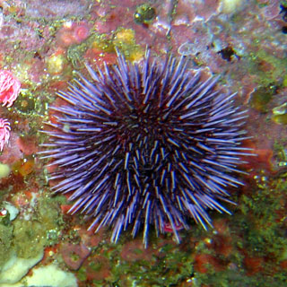
The graphs below and tables on the following two pages compare sea urchin and kelp abundances in areas with and without sea otters (see the map on the first page for locations). Although sea otters formerly were found at all of these locations, they were exterminated from most of their range by hunting during the 19th century. Amchitka and Adak Islands in the Aleutians were locations of some of the few remnant populations at the time otters were protected in the early 1900s. Sea otters were then re-introduced to southeast Alaska in 1968-71. This new population expanded into Surge Bay by the early 1970s and into Torch Bay in 1985.
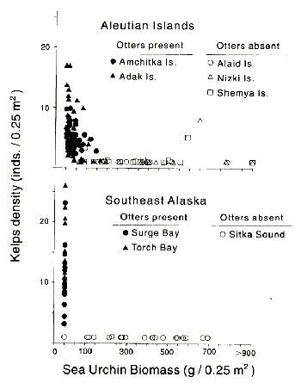
Kelp density (individuals/0.25 m2) plotted against estimated sea urchin biomass (g/0.25 m2) for the Aleutian Islands and southeast Alaska. Points represent averages for sites at each location. Sea urchin biomass was estimated from samples of population density, size-frequency distribution, and the relationship between urchin diameter and wet mass. (From Estes, J.A., and D.O. Duggins. 1995)

Abundance and population characteristics of kelps and sea urchins at two locations in the Aleutians, Amchitka and Shemya Islands, in 1972 and 1987 (shown as means ± 1 standard error). The same four sites at Amchitka and two sites at Shemya were sampled in both years*. Sea otters were continuously abundant at Amchitka and absent from Shemya during the 15-yr period. (From Estes, J.A., and D.O. Duggins. 1995.)

Amchitka Island Shemya Island

Kelp species (inds./0.25 m2) | 1972 | 1987 | 1972 | 1987
Alaria fistulosa | 1.6 ± 1.30 | 0.3 ± 0.22 | 0 | 0.5
Laminaria spp. | 2.3 ± 0.49 | 3.9 ± 0.95 | 0 | 0
Agarum cribrosum | 1.2 ± 0.61 | 0.5 ± 0.42 | 0 | 0
Thalassiophyllum clathrus | 0.1 | 0 | 0 | 0
Total kelps | 5.1 ± 0.66 | 4.7 ± 1.15 | 0 | 0.5
Sea urchins  Maximum test diameter (mm) | 30.5 ± 1.34 | 27.3 ± 3.24 | 72.5 ± 0.71 | 70.5 ± 4.95
Biomass (g/0.25 m2) | 45.1 ± 16.9 | 36.7 ± 15.0 | 368.2 ± 151.7 | 369.3 ± 14.3
Density (inds./0.25 m2) | 27.9 ± 14.5 | 23.4 ± 7.5 | 50.0 ± 14.6 | 38.6 ± 1.4

*The 1972 data were obtained from 10 haphazardly placed 0.25-m2 quadrats/site, the 1987 data from 20 randomly placed 0.25-m2 quadrats/site.

Abundance and population characteristics of kelp and sea urchins at two locations in southeast Alaska, Torch Bay (1976-1978) and Surge Bay (1978 and 1988), shown as means ± 1 standard error. Sea otters were continuously absent at Torch Bay and present at Surge Bay during these time periods. (From Estes, J.A., and D.O. Duggins. 1995.)

 | 1976 | Torch Bay  1977 | 1978 | Surge Bay  1978 1988
Kelps (inds./m2)  Annuals* | 2.1 ± 1.39 | 0.2 ± 0.25 | 11.6 ± 6.69 | 2.1 ± 0.45 3.7 ± 2.34
Perennials** | 0.1 ± 0.11 | 0 | 0.9 ± 1.14 | 48.4 ± 6.33 50.3 ± 7.46
Total | 2.2 | 0.2 | 12.5 ± 5.56 | 50.5 ± 6.43 54.0 ± 9.33
Sea urchins (inds./m2)
S. franciscanus | 3.6 ± 3.05 | 3.8 ± 2.55 | 4.9 ± 3.71 | 0 | 0
S. purpuratus | 1.0 ± 0.75 | 2.3 ± 2.52 | 0.3 ± 0.41 | 0 | 0
S. droebachensis | 3.4 ± 2.24 | 1.5 ± 0.95 | 0.2 ± 0.18 | 0.02 | 0.04
Total | 8.0 ± 4.56 | 7.6 ± 5.78 | 5.4 ± 4.27 | 0.02 | 0.04

*Primarily Alaria fistulosa and Nereocystis leutkeana.
**Primarily Laminaria groenlandica.

The table below summarizes data from several studies on the diet of sea otters.

Occurrence of prey items in sea otter stomachs and feces. (From Estes, J.A., N.S. Smith, and J.F. Palmisano. 1978. "Sea otter predation and community organization in the western Aleutian Islands, Alaska." Ecology 59:822-833.)
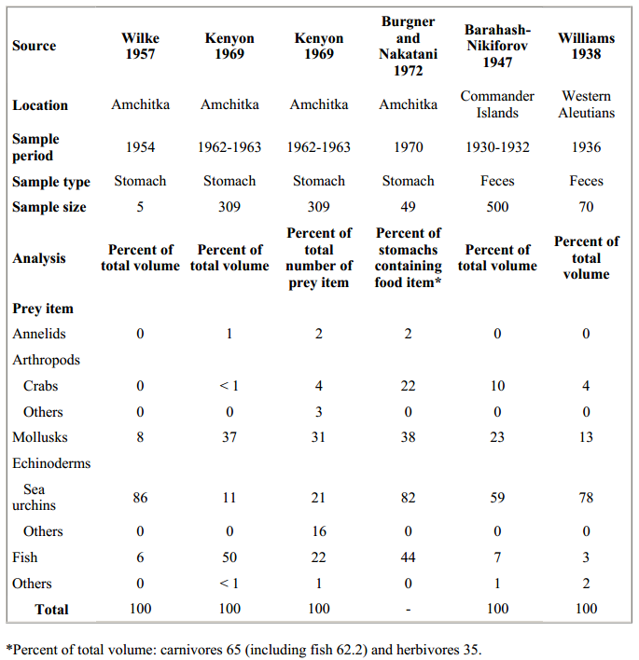

- What do these data tell you about the role of sea otters in their community? Include in your answer a description of how you think sea otters are affecting the two other groups of species (urchins and kelp), as well as a description of what effect you expect sea otters to have on the rest of the kelp forest community.

- The data in the graphs above paint a pretty clear picture, but they are only descriptive data, as opposed to experimental results based on manipulation of an independent variable. As a result, any inferences about the role of otters in their communities are somewhat limited.

Otters are a protected species in Alaska, B.C. and California, and researchers wouldn’t be allowed to manipulate otter numbers for experimental purposes. However, imagine that you were granted exceptional permission to relocate otters between colonies in order to set up the necessary conditions for an experiment to examine otter effects on kelp community structure. With this permission in hand, design an experiment to test the hypothesis that otters are a keystone species in kelp communities. . In your answer to this question, make sure to and indicate any controls in the experimental design that would be used to validate the results, and to identify the independent and dependent variables, as well as variables that should be controlled (as well as possible).

Experimental Design:

Independent Variable:

Dependent Variable:

Control Variables (at least two):

The table below displays all of the species or groups of species encountered so far in this ‘story’, along with their approximate mass per individual, and estimated numbers of individuals found within the same 10 Km² area surrounding Kuluk Bay. Phytoplankton consists of photosynthetic bacteria and microscopic protists; “kelp fish” is a broad category, and will be considered as fish that eat kelp or other algae, while being eaten by bigger fish like perch or pollock. Several of the animal species are transient, so estimates are of the number of given organisms of this species within the area at any given time. Use the data from this table to answer the next two questions.
Organism | Mass per Individual (Kg) | Number Estimated
Killer Whales | 4500 | 4
Sea Lions | 400 | 5
Seals | 200 | 10
Otters | 28.5 | 200
Ocean Perch | 1.5 | 1500
Herring | 3 | 2000
Pollock | 2 | 7500
Kelp Fish | 0.5 | 15000
Urchins | 0.1 | 1000
Kelp Invertebrates | 0.000001 | 1E+11
Baleen Whales | 36000 | 2
Kelp | 5 | 15000
Phytoplankton | 0.000000001 | 1E+15

- Draw a food web of the broad Aleutian Islands aquatic community. Include in the diagram all of the species or groups of species encountered so far: otters, killer whales, ocean perch, herring, Pollock, steller sea lions, harbor seals, baleen whales, plankton (let’s say just the photosynthetic phytoplankton), kelp, kelp fish (yes, this is extremely broad; let’s just say the “kelp fish” eat kelp or other algae, and are eaten by bigger fish like perch or pollock), kelp invertebrates, and urchins. In your web, identify each organism as a primary producer (pp), a primary consumer (1), a secondary consumer (2), etc.

- Using the data from the table above, draw a biomass pyramid for the aquatic ecosystem. In your pyramid, be sure to indicate the number of organisms you’ve assigned to each level, the overall mass of organisms at each level, and the approximate energy transfer efficiency between each level.

