“Light, Camera & Action” – Non-Cyclic Light Reactions in Photosynthesis – Character List
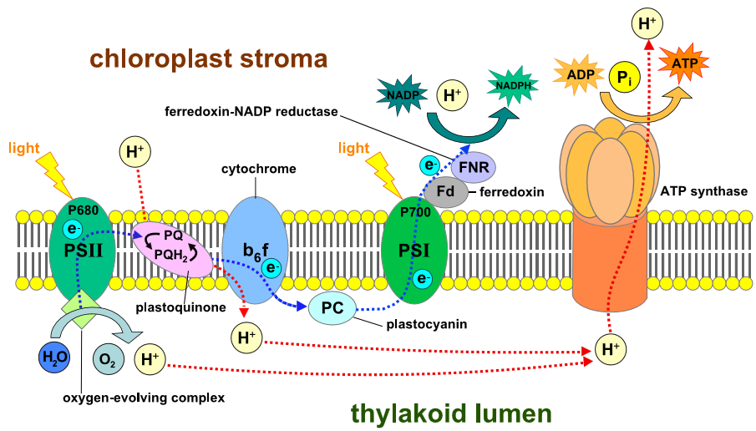
1
1

Thylakoid Membrane
PIGMENT MOLECULES
PIGMENT MOLECULES
16
14
13
12
11
10
9
7 – 8
5 – 6
4
3
2
15
+
- The sun - providing photon energy. 1 student who will "activate" both the reaction centers (PSII & PSI)

- Water. 1 student with 2 tennis balls representing 2 electrons

3 Chlorophyll a molecules in p680/PSII. 1 student represents both special chlorophyll a molecules in p680. This student starts off with 2 tennis balls representing 2 electrons

- Primary electron acceptor in p680. 1 student

- – 8 Protein complexes that are part of the electron transport chain between PSII & PSI. 4 students in 2 pairs. In each pair, 1 student accepts the 2 tennis balls while the other is "activated" to move a handful of chocolate loonies representing the hydrogen ions from the "stroma" box to the "thylakoid lumen" box.
NOTE: students 5 – 8 are directed to work in pairs – all other students receive minimal direction. The green painter’s tape represents the thylakoid membrane – all students are told that this is a phospholipid barrier but not in which direction the hydrogen ions (chocolate loonies) are to be moved by active transport or facilitated diffusion.

- Chlorophyll a molecules in p700/PSI. 1 student - see comments #3 (p680)

- Primary electron acceptor in p700. 1 student
- Ferredoxin complex of the electron transport chain between the primary electron acceptor of PSI and NADP⁺ reductase. 1 student

- NADP+ reductase. 1 student

- NADP⁺. 1 student who is the final tennis balls acceptor. When the student receives the tennis balls from NADP⁺ reductase, the student must switch signs to NADPH

- ATP synthase. 1 student. This student must move a few chocolate loonies from the "thylakoid lumen space" box to the "stroma" box by facilitated diffusion, then must “catalyze” the synthesis of ATP by touching characters 15 and 16

- ADP. 1 student

- P_{i}. 1 student. When “catalyzed” through touch by ATP synthase, ADP and P_{i} form ATP – they must pair up and switch signs to ATP.
NOTE for 13, 15 and 16: students NADP⁺, ADP and P_{i} must be ready on the stroma side of the green painter’s tape.
Remaining students are split into 2 more or less equal groups. They are the pigment molecules of the reaction centers that are "activated" to do the “wave” by the sun’s photons. The 2 groups must be positioned at each side of the classroom so that the last pigment molecule in the wave from each group can touch the special chlorophyll a molecule student in p680 & in p700, respectively.
NOTE for pigment molecules: students must understand that no electrons are passed between these pigments.

