Photosynthesis: Light-Dependent Reactions

Class activity

**PART A (10 min)**

1. If H2O is labeled with radioactive 18O and 3H, what molecule(s) will become radioactive with 18O as non-cyclic electron transport reactions are completed? Which molecule(s) will become radioactive with 3H?
2. Assume a thylakoid is somehow punctured so that the interior of the thylakoid is no longer completely separated from the stroma. This damage will have the most direct effect on which photosynthetic process?
3. How can you tell if a photosynthetic cell has cyclic electron transport only, but not non-cyclic electron transport system?

**PART B: Which light reaction system would a chloroplast favour? Explain. (7 min)**

1. Situation 1: Plenty of light is available, but the cell contains low concentration of NADP+.
2. Situation 2: Plenty of light, but the cell contains high concentration of NADP+.

**PART C: Forest Canopy Photosynthetic Pigments (10 min)**

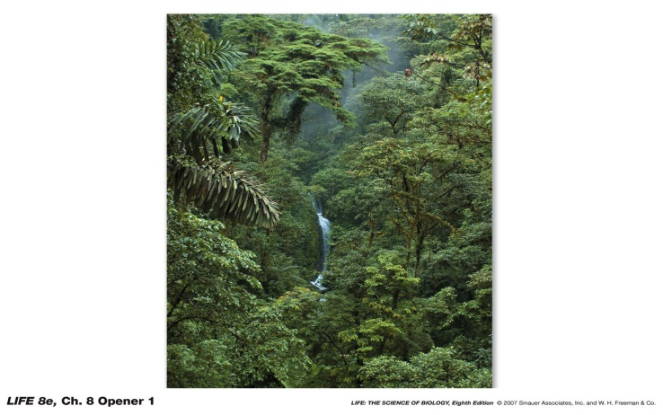Consider plants that occupy the top, middle, and ground canopies (layers) of a forest.

1. Would you expect the same photosynthetic pigments to be found in plant species that live in these different habitats? Why or why not?
2. Would you expect the ratio of chlorophyll a to b to be the same? Why or why not?
3. How would you test your hypothesis?

**PART D: Comparison between non-cyclic and cyclic photophosphorylation (10 min)**

|  |  |  |
| --- | --- | --- |
|  | **Non-cyclic photophosphorylation** | **Cyclic photophosphorylation** |
| **Ultimate electron source** |  |  |
| **Is O2 released?** |  |  |
| **Terminal e- acceptor** |  |  |
| **Form in which energy is temporarily captured** |  |  |
| **Photosystem required** |  |  |