General Biology I (101-NYA)

Population Ecology Concepts & Learning Outcomes
Topic | Concept | Learning Outcomes
What is ecology? | - Ecology is the study of how organisms interact with each other and their environment. | - Define ecology
What are the levels of ecological study? | - Biologists study 4 major levels of ecology:  - Organismal: study of adaptations that allow organisms to interact with its environment and other organisms  - Population level: study of how and why the numbers of individuals in a population change over time  - Community level: study of how different species interact  - Ecosystem level: study the interactions of living organisms with their non-living environment (mainly recycling of matter and energy flow) | - List and describe the 4 levels of ecological study, and explain why these levels are hierarchical
What do ecologists study in a population? | - Population ecologists study how and why the number of individuals in a population changes over time.  - They also study changes in the ages of individuals in a population, the proportion of males to females, and geographic distribution. | - Define population and describe what aspects of population are studied by population ecologists
Population density | - Population density is the number of individuals in a population in a given area.  - For small populations (eg. Elephants), full census is conducted. However, most populations are too big to be counted and therefore the population density is estimated by population sampling using statistical methods.  - If a random sample is properly made (all individuals in a population should have an equal probability to be selected into the sample), it contains no bias and it is therefore relatively representative of the population.  - Two general sampling methods are used in determining population densities:  - Capture-mark-release-recapture method for mobile organisms: % of marked and recaptured individuals = % marked individuals in entire population  - Quadrat or transect method for sedentary organisms (plants and sessile animals) | - Define population density and describe how it is determined in large populations  - Name and describe the 2 general statistical methods used in estimating population densities  - Use proper mathematical methods and calculations (capture-marked-release-recapture and quadrat/transect) to estimate examples of population densities
Population distribution, dispersion patterns | - Dispersion pattern of a population refers to the distribution of individuals in space within a population. Determining the distribution pattern of a population is important to know in order to choose appropriate sampling method.  - There are 3 basic dispersion patterns: clumped, regular, and random. | - Define population dispersion and name, describe, and give examples of the 3 main types of population dispersion
Population growth | - Population growth is the change in the number of individuals in the population (ΔN) per unit time (Δt).  - Rate of increase or growth rate (r) = ΔN/ Δt = birth rate − death rate. If no immigration or emigration is occurring, the r does not change.  - Rate of change in a population size is dependent on the intrinsic rate of growth rate of that population (biotic potential) and available resources (environmental resistance). Therefore, the rate of change = biotic potential x environmental resistance.  - In mathematical terms, the rate of change ΔN/ Δt= r_{max}N = r N (K−N/K). K (also known as the carrying capacity) is the maximum number of individuals in a population that can be supported in a particular habitat over a sustained period of time.  - A population that exhibits decreasing growth as the population approaches the carrying capacity of the environment will display a pattern of growth known as logistic growth | - Recall the formula of exponential growth, define what exponential growth is, and describe what determines a population’s intrinsic rate of increase (r)  - Recall the logistic growth equation, define and explain each term from the equation, including what a carrying capacity (K) is, and describe the effects of changing the various terms on the growth curves  - Draw and label a graph showing logistic population growth  - Perform simple mathematical calculations to predict population sizes using population growth equations
Population types | - Species differ in their capacity to reproduce and therefore in their life history strategies.  - There are 2 general types of populations based on life history strategies: r-strategists and k-strategists.  - r-strategists (high intrinsic rate of growth) characteristics: life is uncertain and the probability of survival to adulthood is very low; therefore they reproduce once, producing large number of offspring. (eg, insects)  - k-strategists (near carrying capacity of environment) characteristics: they are adapted to predictable environment. They are long lived organisms and the probability of survival to adulthood is high. Therefore, they reproduce several times, producing a small number of offspring with each reproductive cycle. (eg, primates) | - Distinguish between species exhibiting r-strategy and k-strategy population growths
Factors affecting population growth rate | - Population densities are determined by 2 general types of factors: density-dependent and density-independent factors.  - Density-dependent factors are a function of population size and therefore are biotic in nature. Examples include predation rates; competition; diseases.  - Density-independent factors are abiotic in nature (irrespective of the numbers of individuals in a population). Examples include cold snaps; hurricanes; drought, global warming. | - Distinguish between density-dependent and density-independent limits on population growth, and provide examples of each
Population dynamics using Leslie matrix analysis | - Population dynamics is the study of the changes in population size through time.  - Survivorship and fecundity are factors used in making projections about future population sizes.  - The Leslie Matrix (also called the Leslie Model) is one of the best known ways to describe the growth of populations (and their projected age distribution), in which a population is closed to migration and where only one sex, usually the female, is considered.  - Leslie matrix is generally applied to populations with annual breeding cycle. It is also used in population ecology to model the changes in a population of organisms over a period of time. In Leslie Matrix Model, the population is divided into groups based on age classes. In the example below the fecundity rate of young adults is 0.6/individual/year, their survivorship is 0.67/individual/year, and their aging rate to older adults is 0.2/individual/year.  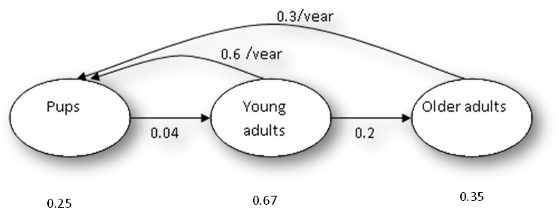 | - Define population dynamics and use Leslie’s matrix in order to calculate population size projections based on fecundity and survivorship of each age class.

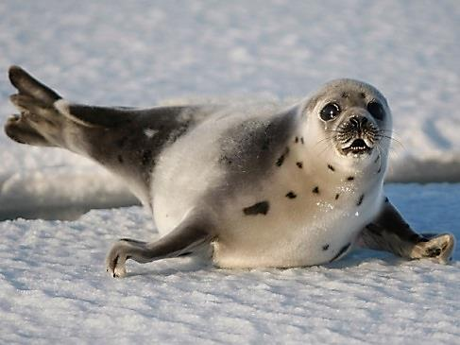
Leslie Matrix Example
The seal population size and its population dynamics in 2015 are depicted below. What would be its size in 2016?
Seal pups: 678,431
Young adults: 251,693
Older adults: 69,875

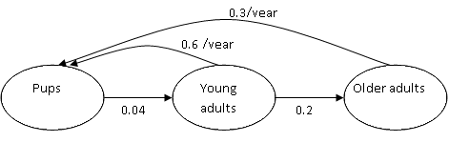
0.67
0.35
0.25

One way of setting up the Leslie matrix for this population is as follows.
Pups Young Older
adults adults
Population size

0 0.01 0.2 0
0.1 0 0 0
0 0.1 0 0
0 0 0.03 0
x

33
50
140
120

=

28.5
3.3
5
4.2

0 0.01 0.2 0
0.1 0 0 0
0 0.1 0 0
0 0 0.03 0
x

33
50
140
120

=

28.5
3.3
5
4.2

0.25 0.6 0.3
0.04 0.67 0
0 0.2 0.35
341,586
195,771
74,795
678,431
251,693
69,875
Pups
Young adults
Older adults

0 0.01 0.2 0
0.1 0 0 0
0 0.1 0 0
0 0 0.03 0
x

33
50
140
120

=

28.5
3.3
5
4.2

X
=

4
2
3
1

In this example, to calculate the number of pups in the 2015 population, multiply the numbers in column “1” by the numbers in column “4”. In other words:
To calculate the number of pups surviving from 2015 to 2016, multiply the population size in 2015 (678431) by their survival rate (0.25): | 169608
To calculate the number of new pups added to the population due to the fecundity of the young adults, multiply the population size of young adults in 2015 (251693) by their fecundity rate (0.6): | 151016
To calculate the number of new pups added to the population due to the fecundity of the older adults, multiply the population size of older adults in 2015 (69875) by their fecundity rate (0.3): | 20962
Predicted population size of pups in 2016: ∑ of the predicted pup numbers from each age class: | 169608 + 151016 + 20962 = 341586

Use the same logic to calculate the predicted 2016 numbers for young adults and older adults.

