How to write a high quality reading annotation

Holistic criteria: A high quality reading annotation evidences that you have read the text and are making an effort to understand the key ideas. In doing so, your annotation will also help others to do the same.

TASK 1:
Use the above holistic criteria to select the best and worst of the 3 student annotations below. Justify your choices.

- Best annotation = S__
- Justification:

- Worst annotation = S__
- Justification:

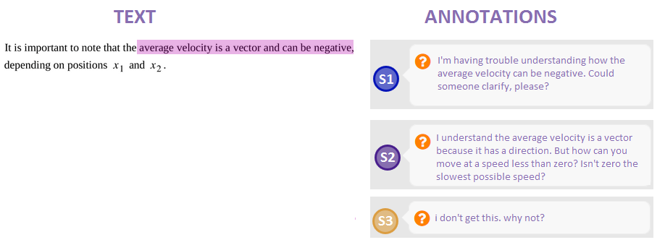

Specific criteria: The holistic criteria will be met and therefore your annotation will be high quality, if you:
- Discuss one or more of the ideas to which your annotation is connected;
- Use scientific terminology where appropriate; and
- Use full sentences with punctuation.

TASK 2:
Which annotation (S1, S2, S3) meets all specific criteria for a good annotation? Which doesn’t meet any of these criteria? How does this relate to your choices in Task 1?

There are many forms a reading annotation can take. The most common are asking questions about the text and answering other students’ questions. These are elaborated on here. Several other useful types of annotations will be discussed later. Read the table below and then use it to complete Task 3.

Table 1: Two most common types of reading annotations: asking and answering questions.
Type | How to write this type of annotation | High quality examples by real students
Ask a question | - State what you understand as well as what you don’t. For example: “I understand … but I don’t understand …” | I understand that as the displacement gradually gets higher, the velocity gets higher, but I don't understand how the slope in the velocity graph correlates to the acceleration graph?
 | - If possible, suggest answers to your question. E.g., “ I don’t understand why …. Could it be because …? | Why would the third ground be placed so far away? Is this a precaution for problems with the generating plant that could affect the device rather than problems with the device itself?
Answer a question | - Answer the question clearly and concisely. | Hi Jon, good question. It is your choice on whether you want to make upwards or downward positive or negative. We usually use downwards as negative, but if you want to use upwards, you have to mention that when you are doing the problems.
 | - If the help-seeker has also proposed an answer, evaluate the answer, providing additional explanation. | I think you somewhat answered your own question Krishna. Yes, it is for safety reasons. If all the connections to the ground were at the same place in the circuit, this could possibly cause problems with the distribution of current. Spreading them out more evenly could prevent the wire from getting too hot.
 | - Refer the help-seeker to another part of the text or provide a link to another helpful resource (e.g. , a video) – but also provide an explanation in your own words. | Sophie, this example I’ve highlighted here could help you understand your previous question. You can see that the person walking walked an excess of 0.75 km passed the initial position which makes the displacement negative. Hope this helps!
 | - Speak directly to the “asker,” remembering that they are a person. For example, use their name and give a positive comment. | [See above examples]

TASK 3:
- Use Table 1 (previous page) to explain how the following “asking questions” type of annotation could be improved. You don’t need to rewrite them, just list the required improvements.
Annotation | How it can be improved
Can some please explain how this equation works?
Here I understand that there are two different forces the translation motion with an acceleration and the rotational motion with acceleration based on the speed of change of its angle but can one affect the other?

- Use Table 1 to explain how the following “answering questions” type of annotation could be improved.
Annotation | How it can be improved
This Khan Academy page answers your exact question: https://www.khanacademy.org/science/physics/linear-momentum/elastic-and-inelastic-collisions/a/what-are-elastic-and-inelastic-collisions
Freja, your explanation makes perfect sense. I’d say you are not as confused as you think you are!

Here are some other ways you can annotate the reading. Read this table then use it to complete Task 4.

Table 2: Other types of reading annotations
Type | How to write this type of annotation | High quality student examples
Clarify | Explain differently:  - Find different/new ways of expressing an idea, don’t just shuffle words around. | So what the text is saying that when the time increases for a given impact, the net force is less powerful due to its magnitude being reduced over a matter of seconds.
 | Summarize:  - Restate the key ideas from a section of the text in your own words, leaving out the less important details | I guess we just need to know that in elastic collisions, the kinetic energy is conserved and in inelastic collisions, it is not. Also, in perfect inelastic collisions, all of the kinetic energy is lost.
 | Give additional useful info:  - Provide anything that could help clarify what is meant, e.g. give missing info or extra examples | Helpful reminder! An electron volt is a measure of energy not of voltage. More precisely, it is the amount of energy that one electron needs to have 1 Volt. In this case, 1 keV is that but multiplied by 1000.
Connect | Connect to another part of the text or another part of the course. | I find this formula really enforces Kirchhoff's Loop Rule. By applying this rule for capacitors too it shows that it is a fundamental law in electricity. We do not only apply it for resistors but for capacitors too. Just like we know Ohm's Law, Kirchhoff's Laws seem to have been the base and foundation of many discoveries in this field.
 | Connect to other courses:  - Remember to discuss relevant science. | It is interesting as well to note the crossover that occurs here between the physics we are learning and the chemistry behind it, the argon gas's electrons are being energized to an excited state, releasing photons and creating light. The one thing I am wondering is, do they still work like that today?
 | Connect to your life:  - Remember to discuss relevant science. | This is really cool! I knew there was a correlation between how a car took an impact in an accident and its safety rating. What I find interesting is the material it is made out of is the main variable in how the car can take that impact. I originally thought the heavier car would have been better in an accident.
Extend | Take the ideas beyond what is expressed in the text or build on a classmate’s ideas.  - Give extra explanation or question going beyond what is taught in the text.  - Get creative – imagine and hypothesize.  - Provide links to other resources.  - Remember to discuss relevant science. | Just a question out of interest. What if there was a third object with which the two other will collide? Could we say that the third object would travel on the z-axis if the third object would be coming in a direction which is out of the paper while the other two objects are traveling from different sides of the x-axis?
Task 4:
Read the paragraph below then make 3 annotations, one of each type discussed in the table on the previous page (clarify, connect, and extend). Use highlighting to “anchor” each annotation to a particular part of the text.

A model is a representation of something that is often too difficult (or impossible) to display directly. Although a model is justified by experimental tests, it is only accurate in describing certain aspects of a physical system. An example is the Bohr model of single-electron atoms, in which the electron is pictured as orbiting the nucleus, analogous to the way planets orbit the Sun. We cannot observe electron orbits directly, but the mental image helps explain some of the observations we can make, such as the emission of light from hot gases (atomic spectra). However, other observations show that the picture in the Bohr model is not really what atoms look like. The model is “wrong,” but is still useful for some purposes. Physicists use models for a variety of purposes. For example, models can help physicists analyze a scenario and perform a calculation or models can be used to represent a situation in the form of a computer simulation. Ultimately, however, the results of these calculations and simulations need to be double-checked by other means — namely, observation and experimentation. [https://openstax.org/books/university-physics-volume-1/pages/1-1-the-scope-and-scale-of-physics]

Annotation 1, Clarify:

Annotation 2, Connect:

Annotation 3, Extend:

