Description and Pedagogy

The activity below is used in an introductory Electricity & Magnetism course. It is an invention activity that prepares students for future learning [1], inspired by the work of Kuo and Wieman [2].
I use the activity as transition from electric field to electric flux. Students are assigned reading assignments about electric flux [3], but typical textbook treatments are fairly abstract. The activity is meant to help alleviate some of the abstractness and does not require understanding of the reading assignment. It can actually be done before the students read about flux.

The activity (see next page) is perhaps a bit unusual, but not difficult. It is best given on a worksheet to facilitate group discussions in lecture. Students are asked to “invent” an equation (in words) that describes how much rain falls through an open window by comparing six cases. Students are usually able to identify the three factors that are important in just a few minutes:
- strength of rain
- window area
- angle between rain direction and window

It is not important that the student are able to generate the “correct” equation because the pedagogy includes a time for telling [3]. So during the follow-up to the activity, the instructor can write something based on students’ responses, such as

amount_of_rain = strength_of_rain x window_area x cos(angle(window, rain_direction))

At this point, we can leave the example by stating that “We can consider the rain passing through the windows as a flux, in this case an amount of something passing through an area.”

Then the equation for electric flux is shown and conceptually discussed by building on the rain example:
- Instead of rain and windows, we have the net number of electric field lines going through a (imaginary) surface.
- Similar to rain example, direction of the electric field and the orientation of the surface important:
Now it is time to introduce the area vector $\vec{A}$ that contains the area (in m²) and the orientation of the area (i.e. the surface normal vector $\hat{n}$). This is done by the instructor along with a brief review of the dot product.

The next step would be to ask some clicker questions about flux, which eventually leads to Gauss’s law.

From my perspective, the activity has the following benefits:
- it builds on everyday experiences to provide an intuitive understanding of flux
- students are asked to make a connection between concepts and mathematics
- it introduces the electric flux equation when students are prepared for it by building on the much more intuitive rain flux. It thus provides meaning to a fairly abstract concept.

The example is displayed on the next page.
PFL activity to prepare for Electric Flux

Rain is falling on three houses with six open windows. In the figure, the large windows have twice the area as the small windows and the heavy rain is twice as strong as the light rain. Your task is to come up with an equation that describes the amount of rain per second coming into each room in the six cases. The numbers near the windows rank the amount of rain from largest to smallest.

Use words in your equation, e.g. "amount = rain ..."
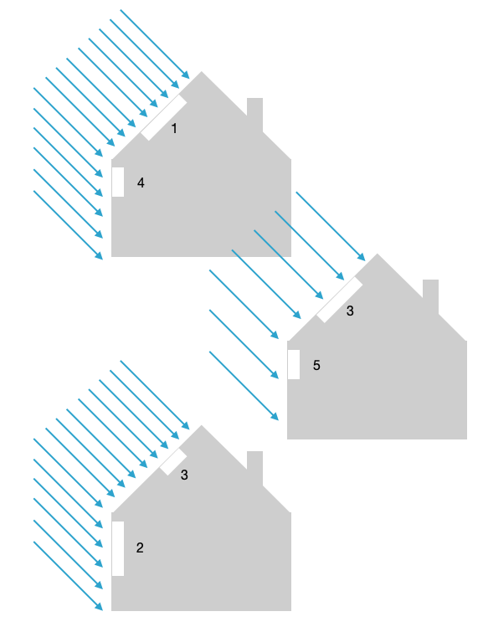
Enter your answer into the box below the figure. After submitting your response, compare your answer to the solution.

- References:
- Schwartz, D. L., & Martin, T. (2004). Inventing to prepare for future learning: The hidden efficiency of encouraging original student production in statistics instruction. Cognition and Instruction 22(2), 129-184.
- Kuo, E. and Wieman, C. E. (2016). Toward instructional design principles: Inducing Faraday’s law with contrasting cases. Phys. Rev. Phys. Educ. Res. 12, 010128
DOI: https://doi.org/10.1103/PhysRevPhysEducRes.12.010128
- I use the openstax textbook and assign an excerpt from this section: https://openstax.org/books/university-physics-volume-2/pages/6-1-electric-flux.
- Schwartz, D. L., Tsang, J. M., & Blair, K. P. (2016). The ABCs of how we learn: 26 scientifically proven approaches, how the work, and when to use them.s

Reading (excerpt from openstax University Physics)

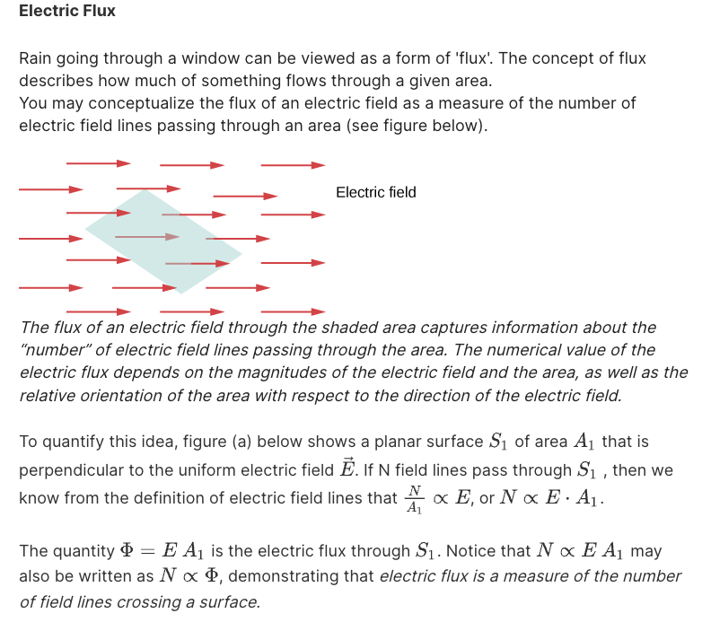

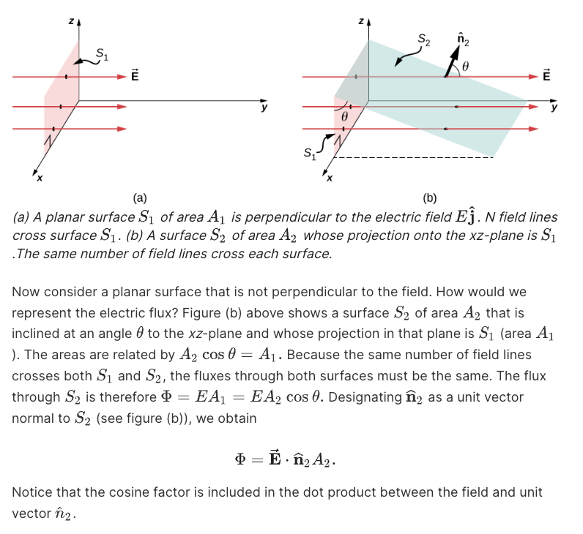

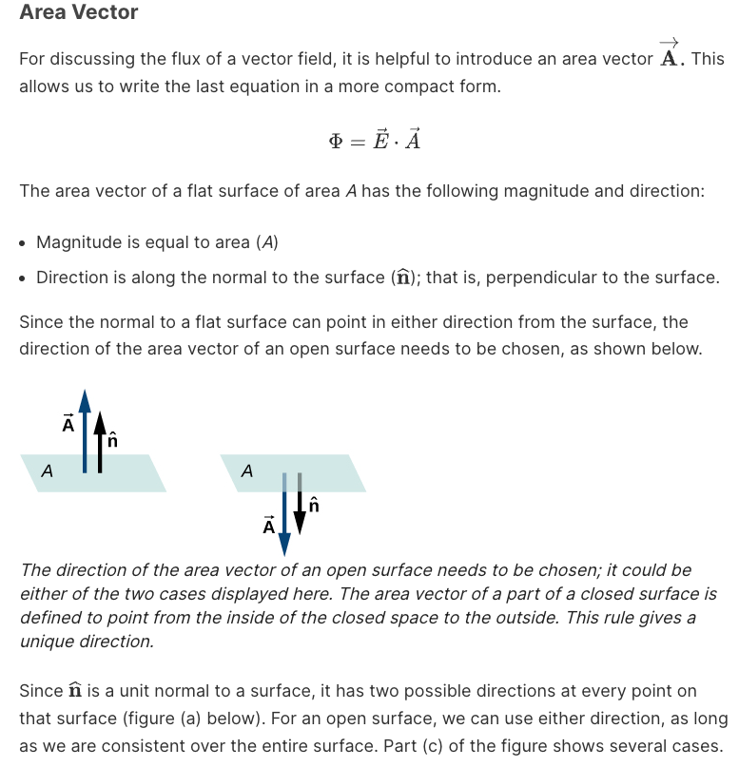

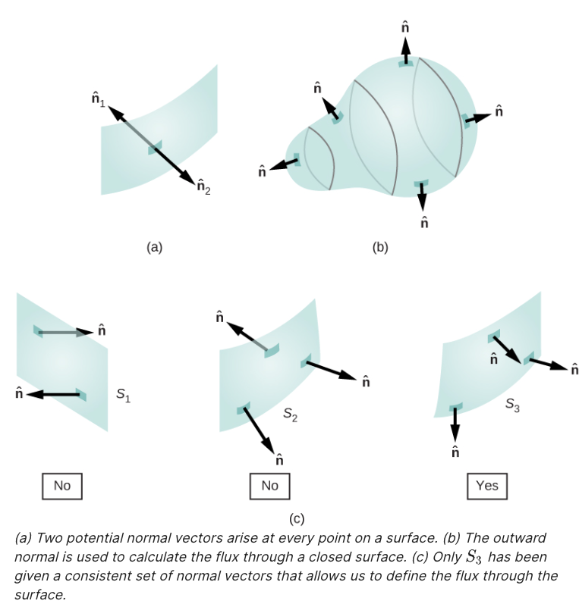

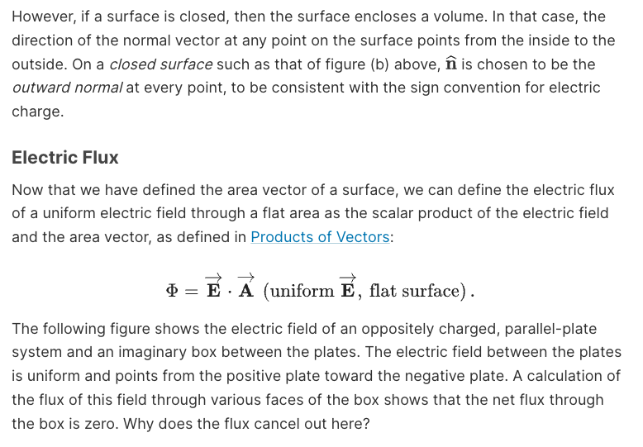

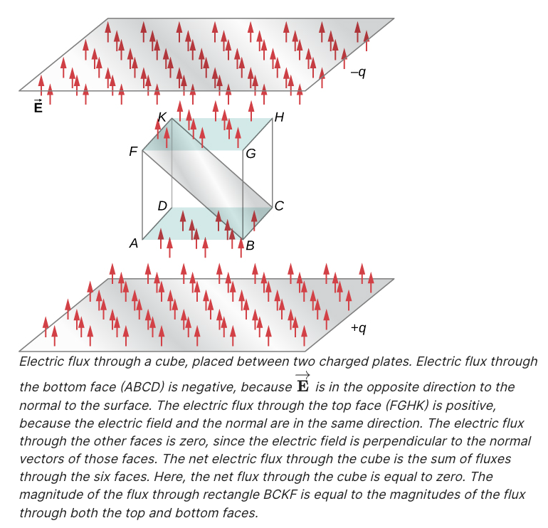
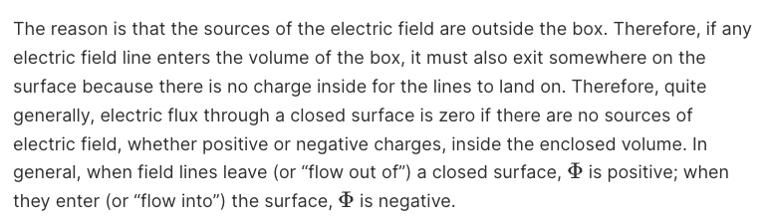
Access for free at
https://openstax.org/books/university-physics-volume-2/pages/6-1-electric-flux.

