PFL activity to prepare for Electric Flux

Rain is falling on three houses with six open windows. In the figure, the large windows have twice the area as the small windows and the heavy rain is twice as strong as the light rain. Your task is to come up with an equation that describes the amount of rain per second coming into each room in the six cases. The numbers near the windows rank the amount of rain from largest to smallest.

Use words in your equation, e.g. "amount = rain ..."
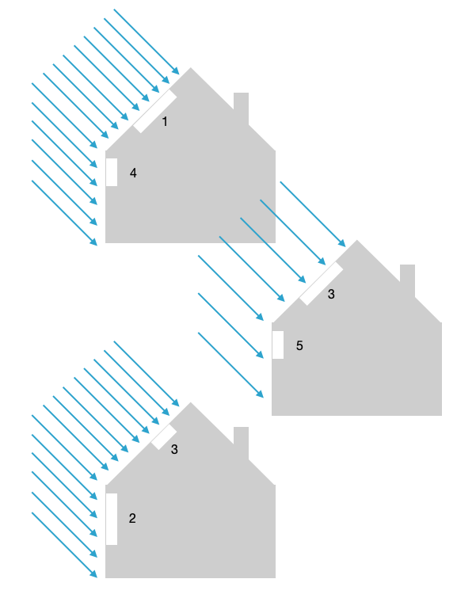
Enter your answer into the box below the figure.

