**Activity (potentially completed as homework)**

Alkaptonuria is an extremely rare disease. The gene for Alkaptonuria (ALK) has recently been shown to lie on human chromosome 9 and to be linked to the gene encoding the ABO blood group, with a recombination frequency of 11% between the loci. A pedigree of a family with the disease is shown below, with affected individuals indicated in black. In addition, the blood type of family members is given.

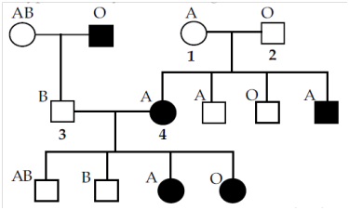

The two alleles at the ALK locus will be denoted + (wild type, no ALK) and - (the ALK allele). The three alleles at the ABO blood group locus will be denoted A, B (which are co-dominant) and O (which is recessive to A and B).

1. What is the genotype of individual 1 at the ALK and ABO loci? **AO+-**

2. What is the genotype of individual 2 at the ALK and ABO loci? Follow the same writing conventions as above. **OO+-**

3. What is the genotype of individual 3 at the ALK and ABO loci? Follow the same writing conventions as above. **BO+-**

4. For individual 3, which alleles of each gene are carried on the chromosome he inherited from his father and which alleles are carried on the chromosome he inherited from his mother? **Father: O- Mother: B+**

5. Individuals 3 and 4 are expecting their fifth child. A physician draws a prenatal blood sample and determines that the child has blood type B. What is the probability that the child will have alkaptonuria? Explain your answer. **11% - Since you know the child has blood type B and has thus inherited the chromosome with the B allele, the only way the child has ALK is if crossing over has occurred and the – allele is attached on the same chromosome.**

What type of inheritance does this pedigree represent, and what is the probability that the child in question (?) will be affected? Assume a ½ probability for each of ?’s mother’s possible genotypes.

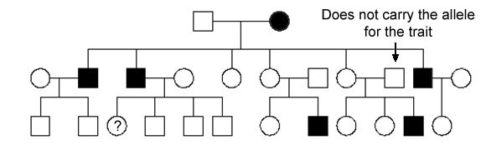

**A.** **X-Linked Recessive, 1/2**

B. X-Linked Recessive, 1/4

C. X-Linked Recessive, 1/3

D. Autosomal Recessive, 1/2

E. Autosomal Recessive, ¼

If the pedigree from the question above represented autosomal recessive inheritance (this is a hypothetical situation… just go with it), and I told you that ?’s grandparents on her mother’s side (?’s mother’s parents) were both heterozygous for the trait, what would you estimate to be the probability of ‘?’ expressing the recessive phenotype?

A. 1/2

**B. 1/3**

C. 1/4

D. 2/3

E. 1/6