**Cycles of matter: Lecture 24**

**Use the information below to complete a worksheet found at:**

https://docs.google.com/document/d/1pT0iuQvuKPGqgT9b26QZLFoQflLc40cDLXlF9-fk4lY/edit

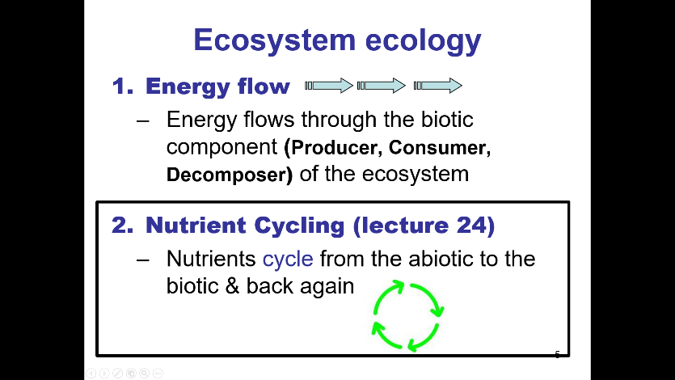

In contrast to energy, matter is **reused & recycled** both **within** and **among ecosystems.**

The **Law of conservation of mass** states that **matter cannot be created or destroyed**; chemical elements therefore are continually **recycled** *within* and *between* ecosystems.

As can be seen in the carbon cycle figure below, **matter can move** from

* **1 organism to another**;
* **1 part of the ecosystem to another**; the biotic to the abiotic & back to the biotic part of the environment.

We therefore say that matter is cycled 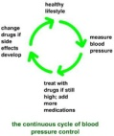, while energy flows through a system with much of the energy being lost at each transfer (trophic level) to the environment as heat (recall cellular respiration).

We will focus on 4 cycles, 3 of which have gaseous components and so **circulate over large areas**: **carbon, nitrogen** and **water**. **Phosphorus doesn’t have a gaseous form**, so it is cycled locally only.

**See learning objectives for Ecology to know what to focus on**.

**1. CARBON CYCLE**

Carbon is **fixed** into organic molecules during photosynthesis (roughly **CO2** + H2O + Sun’s Energy→ **C**6H12**O**6 + O2).

**Carbon is released during cellular respiration** (**C**6H12**O**6 + O2 → **CO2** + H2O + ATP + Heat Energy), by **consumers**, **decomposers** and by the **producers** (they do cellular respiration too).

It’s also released by the burning of **wood** and **fossil fuels** such as **coal, peat moss**,and **oil**, all of which are **end products of photosynthesis;** coal from (example) compressed ferns, peat from partially decayed trees, sphagnum peat moss and grasses, and oil from diatoms. These fuels are said to be non-renewable because it takes so long to accumulate to any appreciable degree (ex. estimated the current sources of oil made 150-400 million years ago).

Carbon is essential to life; it's needed by every living cell (**organic molecules**: proteins, nucleic acids, lipids, CHOs, vitamins). It is also found in the **atmosphere as CO2** and is also present dissolved in **water** & **rocks**.

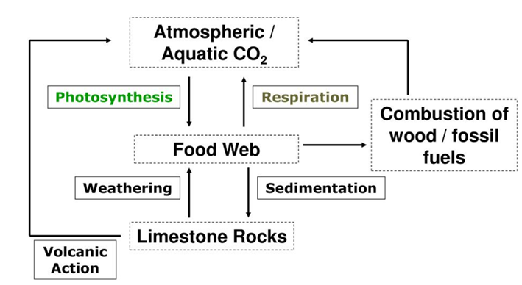

**Figure 1**. The carbon cycle. Note that the term respiration refers to cellular respiration, not breathing, so any organism, including fungi, that do cellular respiration, will release CO2 into the air. Note also that **bacteria**, as well as yeast, perform a type of metabolism called alcoholic fermentation (no, they’re not alcoholics), which produces **CO2** as a by-product. Alcoholic fermentation is also known as ethanol fermentation.

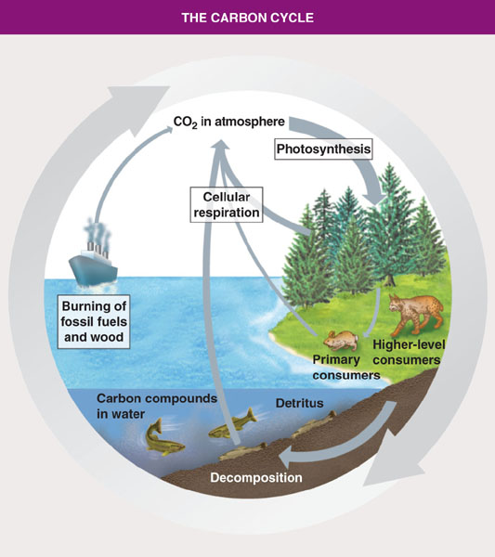

**An example**

Carbon transformations occur everywhere. Plants are **photosynthesizing**, generating *organic* carbon from carbon dioxide. Organic carbon is being transformed into other organic biomolecules within plants, and between organisms through processes such as digestion and biosynthesis (ex. carbon in plants transferred to herbivores or carbon in herbivores transferred to carnivores). The same processes take place in water.

The organic carbon is converted into inorganic carbon (ie CO2) through **cellular respiration**.

**2. NITROGEN CYCLE**

**N2** is **crucial for all organisms** because it’s part of **proteins, nucleic acids** and **chlorophyll** (used for photosynthesis). The nitrogen cycle is the biogeochemical cycle by which nitrogen is converted into multiple chemical forms as it circulates among atmosphere, terrestrial, and marine ecosystems. The conversion of nitrogen can be carried out through both biological and physical processes (weathering of rocks).

Earth’s atmosphere is 78% N2, but **plants can’t use N2** (it’s too stable to be used in synthesis reactions). So N2 must be converted to ammonia (NH3).

There are five steps in the nitrogen cycle

1. **Nitrogen fixation**: convert **nitrogen gas to ammonia** (N2→NH3). Carried out only by certain **bacteria**.
   * This occurs in the roots of certain plants (ie in symbiotic relationships)
   * NEW: a protist has been discovered that can also do this: https://www.nature.com/articles/d41586-024-01046-z
2. Nitrification (ammonia to nitrate: NH3→NO3-). Carried out by certain **bacteria** and archaeans.
3. **Assimilation**: nitrogen into proteins and DNA.
4. Ammonification: **bacteria or fungi** convert the **organic nitrogen** (part of proteins, DNA etc) within the remains of dead organisms back into ammonium.
5. Denitrification: conversion of nitrate (NO3-) to nitrogen gas (N2): **returns N2 to the atmosphere**.

In terms of these 5 steps, I only want you to remember that **bacteria** are needed for almost all of the steps, and that biological **nitrogen fixation** involves converting **N2 into** **ammonia** (NH3).

Note also that the nitrogen in food webs comes from many sources, including fixation of N2 by bacteria, nitrate in the soil, & ammonification of nitrogenous waste.

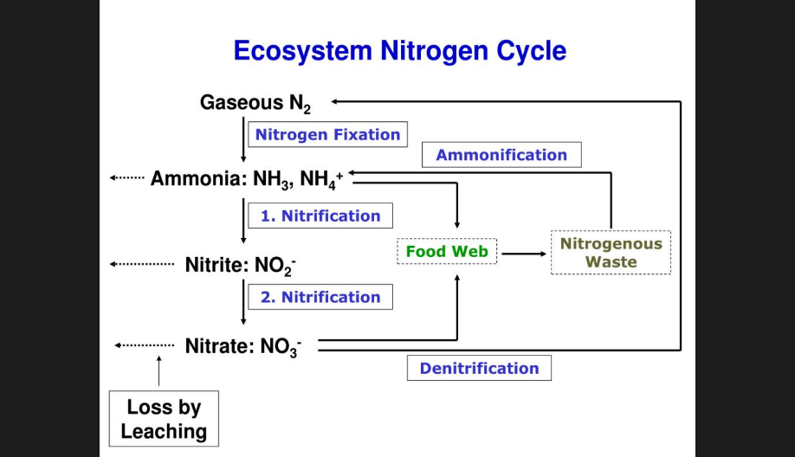

**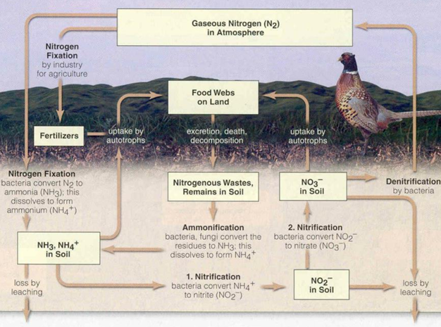**

**Nitrogen cycle, an example.** Take home for nitrogen cycle:

See text in bold on page 2.

**3. PHOSPHOROUS CYCLE**

Phosphorous is found in **nucleic acids, phospholipids, & ATP**.

It erodes from rock as inorganic phosphate (PO4), which plant roots absorb.

Animals get the phosphorus they need from their diets. Decomposers release PO4 into the environment.

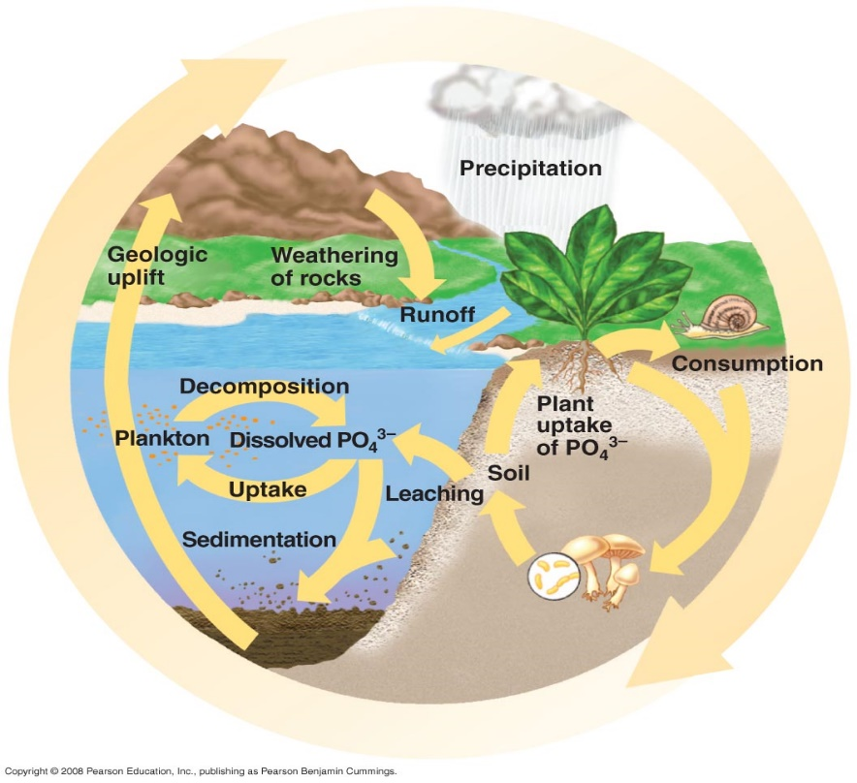

**4. WATER CYCLE**

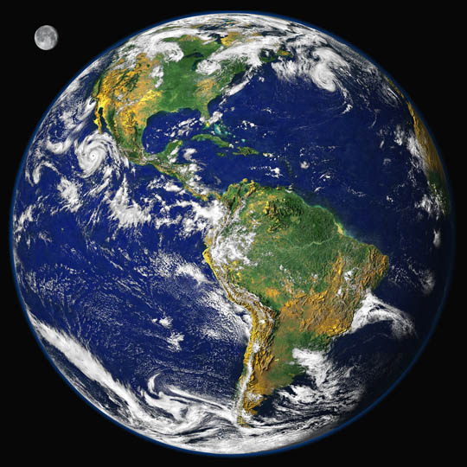

Water everywhere!

FYI Cool fact: Over land, 90% of water that reaches the atmosphere is moisture that has passed through plants via evapotranspiration. (Brooker et al, Biology, Canadian edition, 2010, p1294)

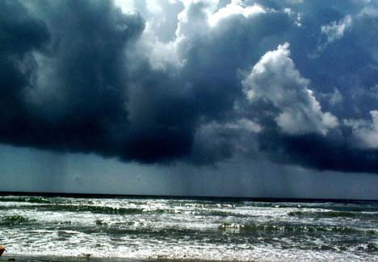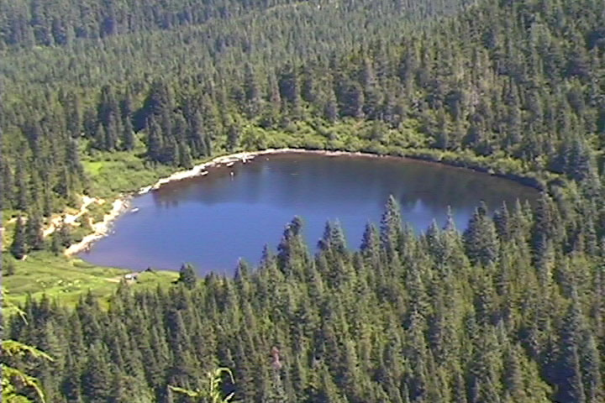

|  |  |
| --- | --- |
| http://media.nowpublic.net/images/64/e/64e6da62b3b1219861f1be318e472141.jpg | **Exchange** of water between  -Land  -Water  -Organisms  **Continually renews** the supply of water essential to life  Changes from a solid (ice) to liquid to gas  FYI: 97% of the water on earth is in the oceans.  Freshwater (rivers, lakes, glaciers): only ~ 3% of the water on earth. |

|  |  |
| --- | --- |
| 54_17WaterCycle_L.jpg | **Precipitation** onto land & bodies of water  **Evaporation** from land & bodies of water  **Transpiration** from plants |

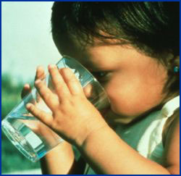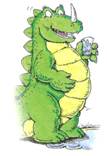

Think about it: the water you drink today has been around for billions of years!

Check out: http://www.youtube.com/watch?v=rf5iHqT1Rzc (plastic bottles)

**Putting it all together**

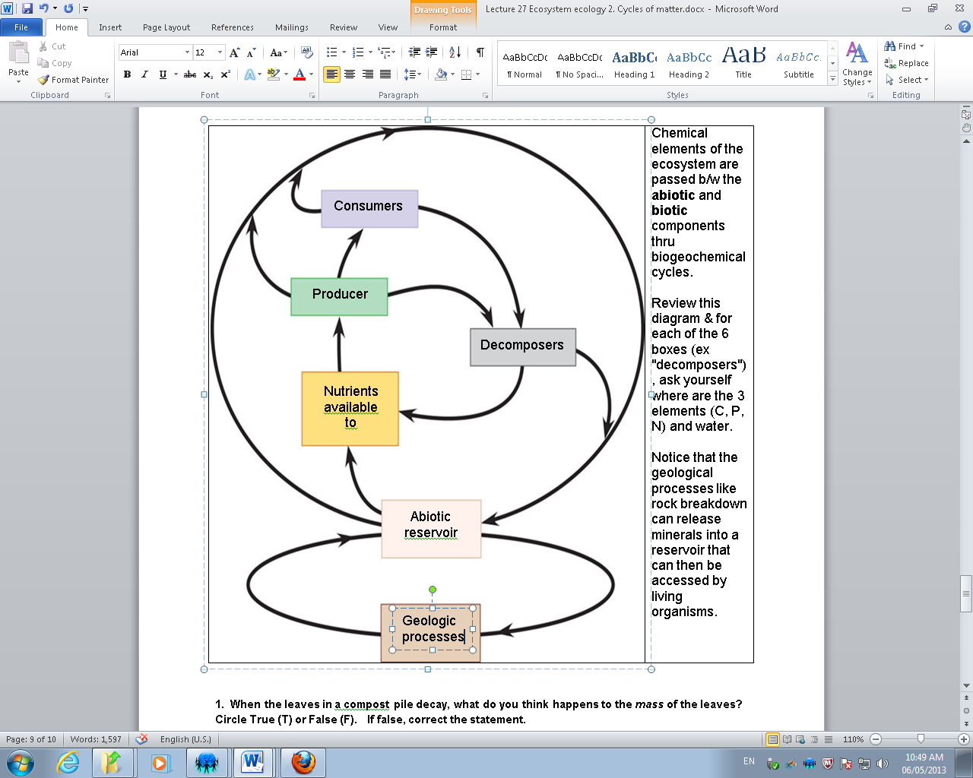

Chemical elements of the ecosystem are passed **back and forth** between the **abiotic** and **biotic** components through biogeochemical cycles.

Review this diagram & for each of the 6 boxes (ex "decomposers"), ask yourself where are the 3 elements (C, P, N) and water.

Notice that the geological processes, like rock breakdown, can release minerals into a reservoir that can then be accessed by living organisms.

You will use the information in this document to complete a worksheet online (Google doc). See link at the top of page 1.