Electron Odyssey: Journey through the Mitochondrial Electron Transport Chain
Detailed Instructions for Instructors

Items required to run this activity:
- Masking tape
- Character cards (printed)
- Detailed Instructions for Instructors (this document)

Before Class:

Print the “Character cards” needed for acting out the mitochondrial electron transport chain (ETC). A detailed explanation of the meanings behind all character cards can be found at the end of this document in Appendix I.

Cards with two terms on them split by a line should be folded in half. They represent a change that occurs during the process. Other character cards should be cut out.

Read through the “During Class” instructions below and decide which options to pursue.

You can choose to print out one copy of the “Character cards” and have a single group of students act out the process, or you can break the class into groups of 7-10 students and print out multiple copies of the cards to have multiple groups going through the process separately.

During Class:

Initial Setup
- Randomly hand out character cards to students.
- Position the protein complexes that are found in the inner membrane:
They should be positioned from left to right as viewed from the classroom as indicated in Figure 1, below.

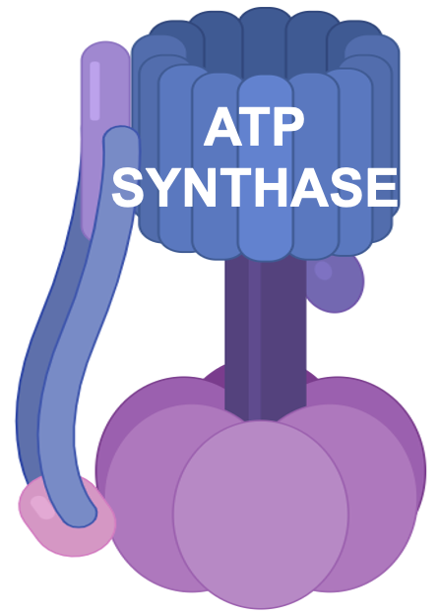
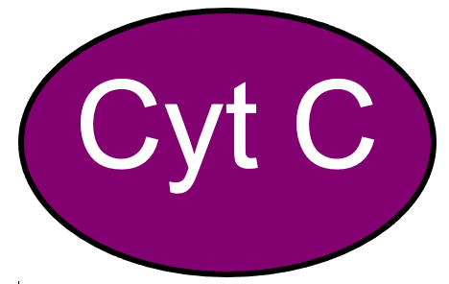
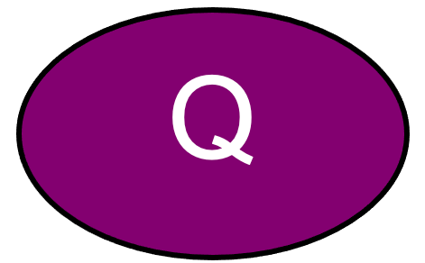
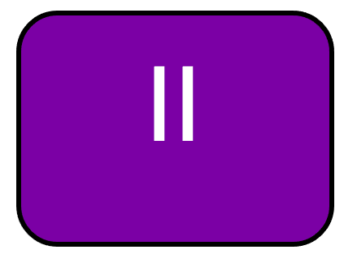
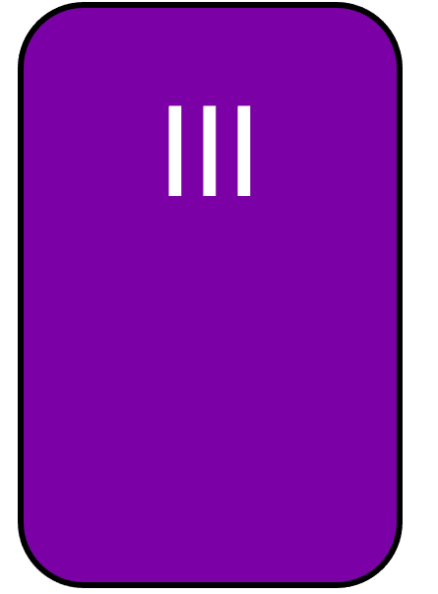
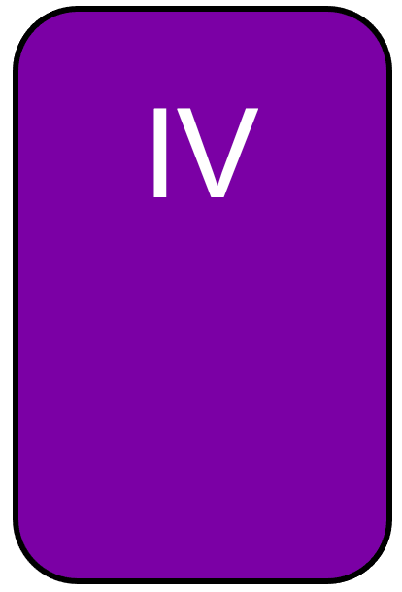
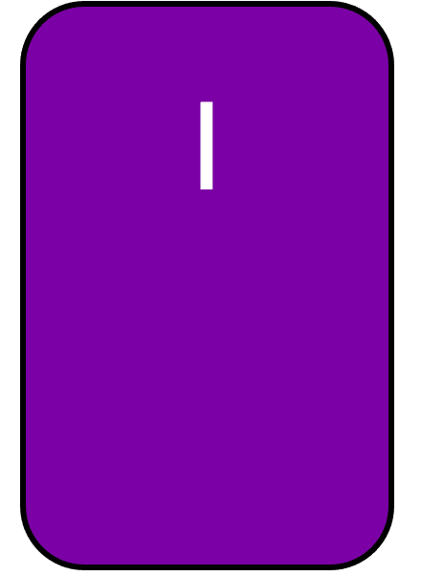


Figure 1: The setup for the ETC activity in class. Students should be set up in this order with the indicated character cards taped to their torsos, if possible. Note that the student wearing the PCII card should be seated in front of the student wearing the Q card. All other students should be standing, if possible.

Acting out the electron transport chain and chemiosmosis in the mitochondrion
Now that everyone is properly positioned in the inner mitochondrial membrane, walk through the process step by step. With each step, explain what you are doing to the students or engage them in the process by asking them to describe what each character should do.

While the steps remain the same, there are a few variations on how you can proceed.

Option 1: Instructor led. Guide the class through each step. Either tell the students what is happening or ask the students involved or those still seated what should happen next. This is the ideal option for the first time performing the activity.

Option 2: Run through the activity a second time with a student driving the proves, or have each student involved explain what is happening in their step.

Option 3: Shuffle the cards and repeat the entire activity with each student taking on a new role. Have the students run the process.

The steps (terms in bold are the character cards, and terms in italics are instructor directions).

Step-by-Step Instructions for NADH:
- NADH becomes NAD⁺ + 2 H (whomever is holding the NADH card turns it so that the NAD⁺ + 2 H is facing the audience)

- 2 H separates into 2 e⁻ and 2 H⁺ (Teacher gives 2 e⁻ and 2 H⁺ to whomever is holding the NAD⁺ + 2 H card)

- 2 e⁻ are given to Protein Complex I (whomever is holding the NAD⁺ + 2 H card gives 2 e⁻ to student wearing the PCI card)

- 2 e⁻ are given from Protein Complex I to Ubiquinone (student wearing the PCI card gives 2 e⁻ to student wearing the Q card)

- Energy released from 2 e⁻ going to Ubiquinone is used to pump 4 H⁺ from the mitochondrial matrix to the intermembrane space (Teacher gives student wearing the PCI card 4 H⁺; Student wearing PCI card lifts 4 H⁺ from below waist to above head, signifying to pumping of protons from the matrix to the intermembrane space. They hold the protons above head as long as is possible).

- 2 e⁻ are given from Ubiquinone to Protein Complex III (student wearing the Q card gives 2 e⁻ to student wearing the PCIII card)

- 2 e⁻ are given from Protein Complex III to Cytochrome C (student wearing the PCIII card gives 2 e⁻ to student wearing the Cyt C card)

- Energy released from 2 e⁻ going to Cytochrome C is used to pump 4 H⁺ from the mitochondrial matrix to the intermembrane space (Teacher gives student wearing the PCIII card 4 H⁺; Student wearing PCIII card lifts 4 H⁺ from below waist to above head, signifying to pumping of protons from the matrix to the intermembrane space. They hold the protons above head as long as is possible).

- 2 e⁻ are given from Cytochrome C to Protein Complex IV (student wearing the Cyt C card gives 2 e⁻ to student wearing the PCIV card)

- 2 e⁻ are combined with oxygen and H⁺ to make water (Student wearing PCIV card gives 2 e⁻ to whomever is holding the 2 H⁺ + ½ O₂ + 2 e⁻ card; whomever is holding the 2 H⁺ + ½ O₂ + 2 e⁻ card turns it so that the H₂O is facing the audience)

- Energy released from 2 e⁻ going to water is used to pump 2 H⁺ from the mitochondrial matrix to the intermembrane space (Teacher gives student wearing the PCIV card 2 H⁺; Student wearing PCIV card lifts 2 H⁺ from below waist to above head, signifying to pumping of protons from the matrix to the intermembrane space. They hold the protons above head as long as is possible).

We have built a proton (H⁺) gradient across the inner membrane of the mitochondria. Protons want to return to the matrix to reduce the charge difference. The protons can only move from the intermembrane space back to the matrix through ATP Synthase.

- For every 4 H⁺ that move from the intermembrane space to the matrix through ATP Synthase, 1 ATP is formed. (Teacher gathers all 10 H+ from the students, and gives them to student wearing ATP Synthase card 4 H+ at a time. For every 4 H+ given to ATP synthase, whomever is holding the ADP + P card turns it so the ATP is facing the audience).

Potential probing questions teacher can ask students following completing the above steps:

- How much ATP can be produced from one NADH donating its electrons to the electron transport chain?
- Answer: Because 10 H⁺ were pumped from the matrix to the intermembrane space, we make a total of 2.5 ATP from the power generated from the 2 e⁻ donated by NADH.

- What are the products of this process?
- Answer: For every NADH donating its electrons to the electron transport chain, we produce 1 NAD+, 1 H₂O, 2.5 ATP

Step-by-Step Instructions for FADH₂:
- FADH₂ becomes FAD + 2 H (whomever is holding the FADH₂ card turns it so that the FAD + 2 H is facing the audience)

- 2 H separates into 2 e⁻ and 2 H⁺ (Teacher gives 2 e⁻ and 2 H⁺ to whomever is holding FAD + 2 H card)

- 2 e⁻ are given to Protein Complex II (whomever is holding the FAD + 2 H card gives 2 e⁻ to student wearing the PCII card)

- 2 e⁻ are given from Protein Complex I to Ubiquinone (student wearing the PCI card gives 2 e⁻ to student wearing the Q card)

- 2 e⁻ are given from Ubiquinone to Protein Complex III (student wearing the Q card gives 2 e⁻ to student wearing the PCIII card)

- 2 e⁻ are given from Protein Complex III to Cytochrome C (student wearing the PCIII card gives 2 e⁻ to student wearing the Cyt C card)

- Energy released from 2 e⁻ going to Cytochrome C is used to pump 4 H⁺ from the mitochondrial matrix to the intermembrane space (Teacher gives student wearing the PCIII card 4 H⁺; Student wearing PCIII card lifts 4 H⁺ from below waist to above head, signifying to pumping of protons from the matrix to the intermembrane space. They hold the protons above head as long as is possible).

- 2 e⁻ are given from Cytochrome C to Protein Complex IV (student wearing the Cyt C card gives 2 e⁻ to student wearing the PCIV card)

- 2 e⁻ are combined with oxygen and H⁺ to make water (Student wearing PCIV card gives 2 e⁻ to whomever is holding the 2 H⁺ + ½ O₂ + 2 e⁻ card; whomever is holding the 2 H⁺ + ½ O₂ + 2 e⁻ card turns it so that the H₂O is facing the audience)

- Energy released from 2 e⁻ going to water is used to pump 2 H⁺ from the mitochondrial matrix to the intermembrane space (Teacher gives student wearing the PCIV card 2 H⁺; Student wearing PCIV card lifts 2 H⁺ from below waist to above head, signifying to pumping of protons from the matrix to the intermembrane space. They hold the protons above head as long as is possible).

We have built a proton (H⁺) gradient across the inner membrane of the mitochondria. Protons want to return to the matrix to reduce the charge difference. The protons can only move from the intermembrane space back to the matrix through ATP Synthase.

- For every 4 H⁺ that move from the intermembrane space to the matrix through ATP Synthase, 1 ATP is formed. (Teacher gathers all 6 H+ from the students, and gives them to student wearing ATP Synthase card 4 H+ at a time. For every 4 H+ given to ATP synthase, whomever is holding the ADP + P card turns it so the ATP is facing the audience).

Potential probing questions teacher can ask students following completing the above steps:

- How much ATP can be produced from one FADH₂ donating its electrons to the electron transport chain?
- Answer: Because 6 H⁺ were pumped from the matrix to the intermembrane space, we make a total of 1.5 ATP from the power generated from the 2 e⁻ donated by FADH₂.

- Why does FADH₂ lead to less ATP being made than NADH?
- Answer: By donating its electrons to Protein Complex II instead of Protein Complex I, the energy from the electrons in FADH₂ lead to a total of 4 fewer protons being pumped into the intermembrane space. This lower contribution to the proton gradient leads to 4 fewer protons diffusing back into the matrix from the intermembrane space, and 1 less ATP being phosphorylated.

- What are the products of this process?
- Answer: For every FADH₂ donating its electrons to the electron transport chain, we produce 1 FAD, 1 H₂O, 1.5 ATP

Potential probing questions teacher can ask students regarding the implications of the events of all electron carriers (NADH and FADH₂) arriving at the electron transport chain.

- Overall, how much ATP can be produced at this final step (electron transport chain and subsequent oxidative phosphorylation) from a single glucose going through aerobic respiration?
- Answer: If you have 10 NADH and 2 FADH₂ from glycolysis and the citric acid cycle, then you would produce a total of 28 ATP during this final step (10 NADH x 2.5 ATP/NADH = 25 ATP from NADH; 2 FADH₂ x 1.5 ATP/FADH₂ = 3 ATP from FADH₂). If you have 8 NADH and 4 FADH₂ from glycolysis and the citric acid cycle, then you would produce a total of 26 ATP during this final step (8 NADH x 2.5 ATP/NADH = 20 ATP from NADH; 4 FADH₂ x 1.5 ATP/FADH₂ = 6ATP from FADH₂).

OPTIONAL Extra activity on inhibitors of the electron transport chain

Inhibitors of the ETC in aerobic respiration block the movement of electrons at certain points in the chain, leading to reduction of ATP production and oxygen consumption. Below are a series of inhibitors of the ETC and explanations of their mode of action.

For the following, the teacher can either challenge a group of students to act out the ETC following addition of each or certain examples of the below inhibitors, or if several groups in the class have been acting out the ETC, the teacher can assign each group one particular inhibitor. It is suggested that, after assigning the inhibitors and describing which component of the ETC they inhibit, that the students be challenged to predict what the outcome would be on the process before the teacher gives them the answer to this.

Inhibitors of the ETC:

Carbon monoxide: Binds to Protein Complex IV, preventing oxygen from binding and stopping the passage of electrons.
- Answer: If electrons cannot be given from Protein Complex IV to oxygen to make water, then Protein Complex IV is stuck in its reduced state. Subsequently, electrons coming down the ETC will no longer be able to be given to Protein Complex IV, so at first Cytochrome C will receive electrons, become reduced, but will not be able to be oxidized because it cannot give its electrons to Protein Complex IV. As more electron carriers arrive at the ETC, eventually all previous ETC components will also be frozen in their reduced states, one at a time. Eventually, carriers will no longer be able to donate their electrons to the ETC, and no protons will be pumped into the intermembrane space, eliminating the proton gradient, and ceasing all ATP production via oxidative phosphorylation.

Cyanide: Binds to Protein Complex IV, blocking the movement of electrons.
- Answer: If electrons cannot be given from Protein Complex IV to oxygen to make water, then Protein Complex IV is stuck in its reduced state. Subsequently, electrons coming down the ETC will no longer be able to be given to Protein Complex IV, so at first Cytochrome C will receive electrons, become reduced, but will not be able to be oxidized because it cannot give its electrons to Protein Complex IV. As more electron carriers arrive at the ETC, eventually all previous ETC components will also be frozen in their reduced states, one at a time. Eventually, carriers will no longer be able to donate their electrons to the ETC, and no protons will be pumped into the intermembrane space, eliminating the proton gradient, and ceasing all ATP production via oxidative phosphorylation.

Rotenone: Binds to Protein Complex I, preventing electrons from transferring to Ubiquinone
- Answer: If electrons cannot be given from Protein Complex I to Ubiquinone, then Protein Complex I is stuck in its reduced state. Any subsequent NADH looking to donate its electrons to the ETC will not be able to do so, because Protein Complex I will be frozen in its reduced state. FADH₂, on the other hand, should be able to donate its electrons to Protein Complex II and function as normal. Overall, there would be a reduced proton gradient and reduced ATP production via oxidative phosphorylation.

Antimycin A: Binds to Protein Complex III, preventing electrons from transferring to Cytochrome C
- Answer: If electrons cannot be given from Protein Complex III to Cytochrome C, then Protein Complex III is stuck in its reduced state. Subsequently, electrons coming down the ETC will no longer be able to be given to Protein Complex III, so at first Ubiquinone will receive electrons, become reduced, but will not be able to be oxidized because it cannot give its electrons to Protein Complex III. As more electron carriers arrive at the ETC, eventually all previous ETC components will also be frozen in their reduced states, one at a time. Eventually, carriers will no longer be able to donate their electrons to the ETC, and no protons will be pumped into the intermembrane space, eliminating the proton gradient, and ceasing all ATP production via oxidative phosphorylation.

Oligomycin: Binds to ATP synthase, preventing protons from flowing through it
- Answer: If protons cannot flow through ATP synthase, no ATP can be made at the ETC through oxidative phosphorylation.

TTFA: Binds to Protein Complex II, blocking the movement of electrons.
- Answer: If electrons cannot be given from Protein Complex II to Ubiquinone, then Protein Complex II is stuck in its reduced state. Any subsequent FADH₂ looking to donate its electrons to the ETC will not be able to do so, because Protein Complex II will be frozen in its reduced state. NADH, on the other hand, should be able to donate its electrons to Protein Complex I and function as normal. Overall, there would be a reduced proton gradient and reduced ATP production via oxidative phosphorylation.

Potential probing questions teacher can ask students following completing the above steps:

- What are some general observations you have made about how inhibitors affect the ETC?
- Answer: After binding with an ETC component, that component can no longer switch from an oxidized to a reduced state. It leads to the accumulation of reduced forms prior to the inhibitor point, and oxidized forms of the components of the ETC down the line of the inhibition point.

OPTIONAL Extra activity on uncouplers of the electron transport chain

For the following, the teacher can either challenge a group of students to act out the ETC following addition of each or certain examples of the below uncouplers, or if several groups in the class have been acting out the ETC, the teacher can assign each group one particular uncoupler. It is suggested that, after assigning the uncouplers that the students be challenged to predict what the outcome would be on the process before the teacher gives them the answer to this.

Uncouplers of the ETC:

In mitochondria, the movement of electrons and production of ATP are tightly coupled reactions. The movement of electrons allows the pumping of protons across the membrane, which creates the proton gradient that allows the production of ATP. Uncouplers do just that: uncouple the connection between the ETC and ATP production. They do so by stopping the synthesis of ATP, while the movement of electrons continues.

Dinitrophenol: Binds with protons and allows them to diffuse across the membrane from high to low concentrations
- Answer: As the ETC progresses, protons are being pumped from the matrix to the intermembrane space to generate the proton gradient that will lead to ATP production. In the presence of this uncoupler, the proton gradient is dismantled as protons are brought back from the intermembrane space to the matrix. Therefore, protons will have no reason to go through ATP synthase, leading to the stoppage of ATP production by oxidative phosphorylation.

Thermogenin: Creates a passive proton pump (UCP-1) within the inner mitochondrial membrane, leading to protons diffusing from the intermembrane space back into the matrix.
- Answer: As the ETC progresses, protons are being pumped from the matrix to the intermembrane space to generate the proton gradient that will lead to ATP production. In the presence of this uncoupler, the proton gradient is dismantled as protons are brought back from the intermembrane space to the matrix. Therefore, protons will have no reason to go through ATP synthase, leading to the stoppage of ATP production by oxidative phosphorylation.
Potential probing questions teacher can ask students following completing the above steps:

- Where does the energy from the electrons usually go, in the absence of uncouplers?
- Answer: As electrons move through the ETC, they are always losing energy. Some of this energy is lost as heat, while some of the energy is used to pump protons from the matrix to the intermembrane space.

- Where does the energy from the electrons go in the presence of uncouplers?
- Answer: The majority of the energy released from electrons arriving to the ETC is released as heat.

- Can you think of a possible utility to uncouplers?
- Answer: Uncouplers allow organisms to produce massive amounts of heat from their food energy in a passive way, that is, instead of shivering. This is actually incredibly helpful for certain endothermic organisms to maintain internal body temperatures (for example, new born animals and hibernating animals).

APPENDIX I. DETAILED EXPLANATION OF CHARACTER CARDS

Below is a table of contents of all cards contained in the “Electron Odyssey - Character cards” file, including a description of what the terms signify, a corresponding picture, and a brief description of who (teacher or student) should be handling the card, and whether it should be held or taped to the individual.

FULL NAME OF COMPONENT | PICTURE OF CARD | - WHO HAS CARD  - WHERE CARD GOES  - NOTES
Nicotinamide-adenine dinucleotide (NADH) | 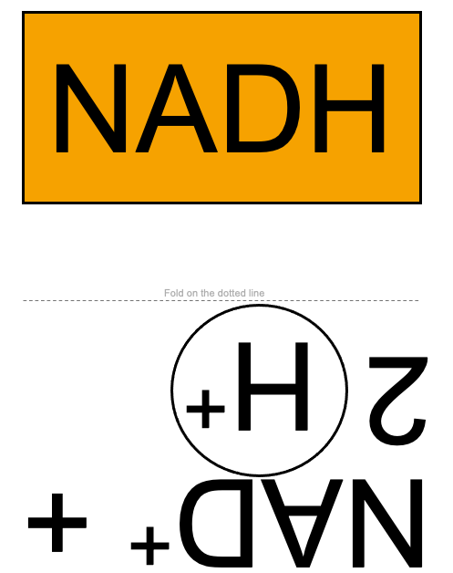 | - Teacher OR student  - Held
Flavin adenine dinucleotide (FADH₂) | 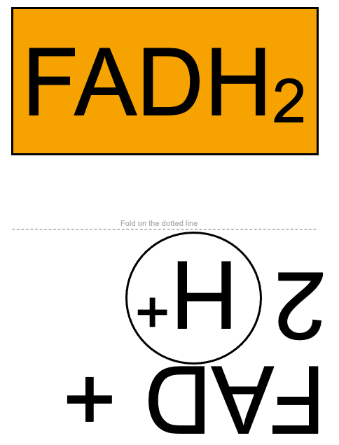 | - Teacher OR student  - Held
Protons (H⁺) | 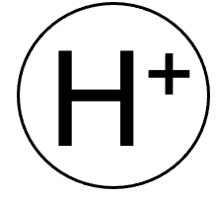 | - Teacher  - Held  - Need 10 (NADH) and 6 (FADH₂); can be reused if doing as one group
Electrons (e⁻) | 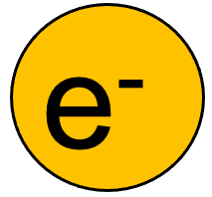 | - Teacher  - Held  - Need 2
Adenosine triphosphate (ATP) | 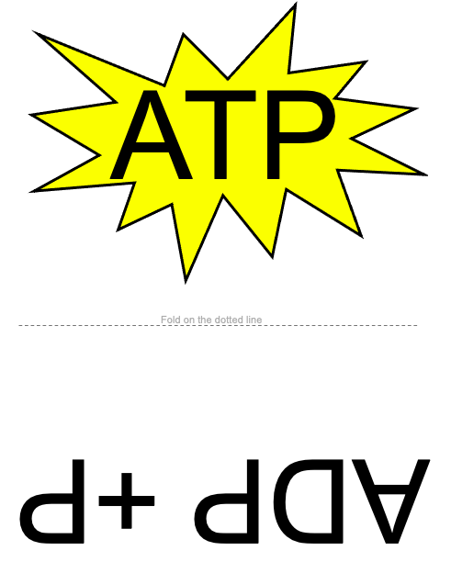 | - Teacher OR student  - Held
Water (H₂O) | 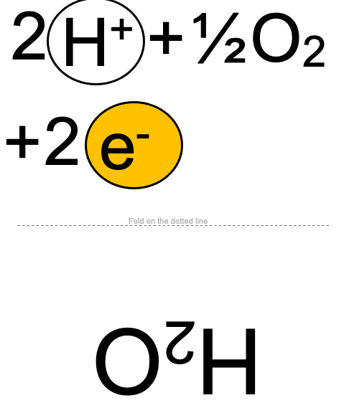 | - Teacher OR student  - Held
Protein Complex I (PCI) |  | - Student  - Taped to torso (if possible)
Protein Complex III (PCIII) |  | - Student  - Taped to torso (if possible)
Protein Complex IV (PCIV) |  | - Student  - Taped to torso (if possible)
Protein Complex II (PCII) |  | - Student  - Taped to torso (if possible)
Ubiquinone (Q) |  | - Student  - Taped to torso (if possible)
Cytochrome C (Cyt C) |  | - Student  - Taped to torso (if possible)
ATP Synthase |  | - Student  - Taped to torso (if possible)

